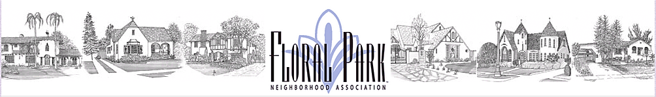
FPNA General Membership Meeting Minutes
Thursday, November 19, 2020 at 7 p.m.
(Via Tele-Conference)

Present: President Jeff Katz
First Co-Vice President Tracey Stein
Second Co-Vice President Chris Switzer
Secretary Angel Barnes
Treasurer Craig Kalthoff-Patti
Parliamentarian Beverley Schauwecker
Social Co-Director Alison DeMark
Social Co-Director Suzee Katz
Membership Co-Director Tammy Heider
Membership Co-Director Kevin Shuler

Call to Order – The November 10, 2020 FPNA General Membership Meeting was called to order at 7:01 p.m. The above Board members attended. Timely notice of this meeting and its purpose of approving the 2021 FPNA Budget, was published by E-blast and on Next Door by Communications Director Marc LaFont. The Budget was likewise timely published by the Treasurer on the FPNA website.

Jeff had also arranged for the C.E.O. of the Discovery Science Foundation, Joe Adams, to give a presentation about the Discovery Cube’s creative plans for growth and improvement on its reopening. Given the recently-postponed reopenings of several Southern California attractions, however, those plans are now being augmented. Thus, Mr. Adams felt it best, and Jeff agreed, to defer that presentation for a few months. Accordingly, the meeting turned to its primary order of business for this evening.

Approval of the 2021 FPNA Budget by Presenter Treasurer Craig Kalthoff-Patti

A Motion was made, seconded and approved at the November 10th FPNA Board Meeting to add the Legacy Committee to the Budget since those Awards are an annual anticipated function that have no allotted funds for the printing and installation of the honorary pavers. The Legacy winners from 2019 and 2020 (which the Board mistakenly believed to be four) have not yet had their pavers installed in Sarah Mae Downie Park, due to no budgeted funds, and there will likely be Legacy nominees in 2021.

Since publication of the Budget, the Treasurer was contacted by the Legacy Committee Co-Chair that $1,000 may be insufficient. There were actually nine 2019 and 2020 winners, not four, and the budgeted amount anticipates about seven pavers, including up to three 2021 winners. Rather than change the published Budget at this juncture, however, and since the cost is $150 or less per paver, the Treasurer felt that he will deal with any shortfall in 2021 and then reassess the amount for the following year’s budget.

Having received no other concerns or corrections regarding any budget item following its publication, Jeff moved that the General Membership approve the 2021 Budget as prepared by the Treasurer. His motion was seconded by Beverley and ALL attendees approved, in their capacity as Floral Park neighbors.

Thus, the General Meeting Adjourned at 7:08 p.m.

